Google Apps

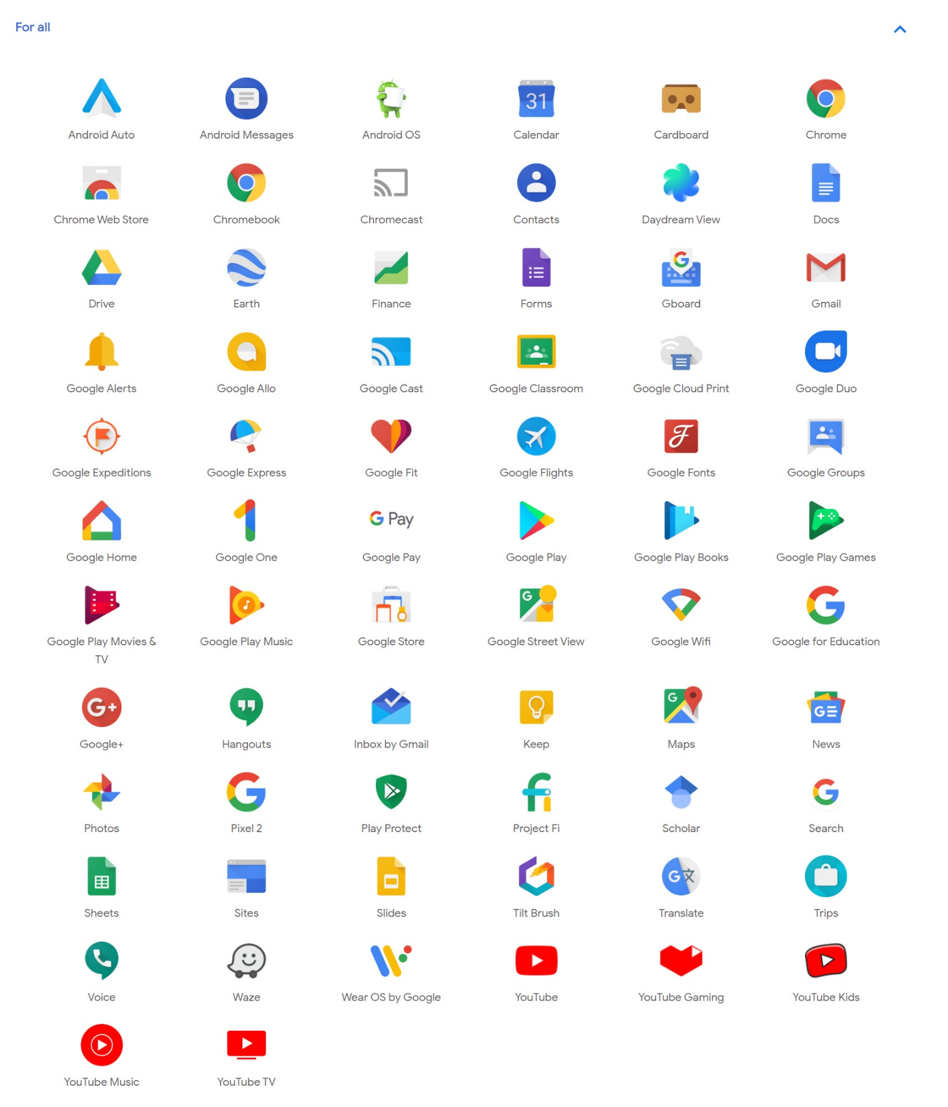

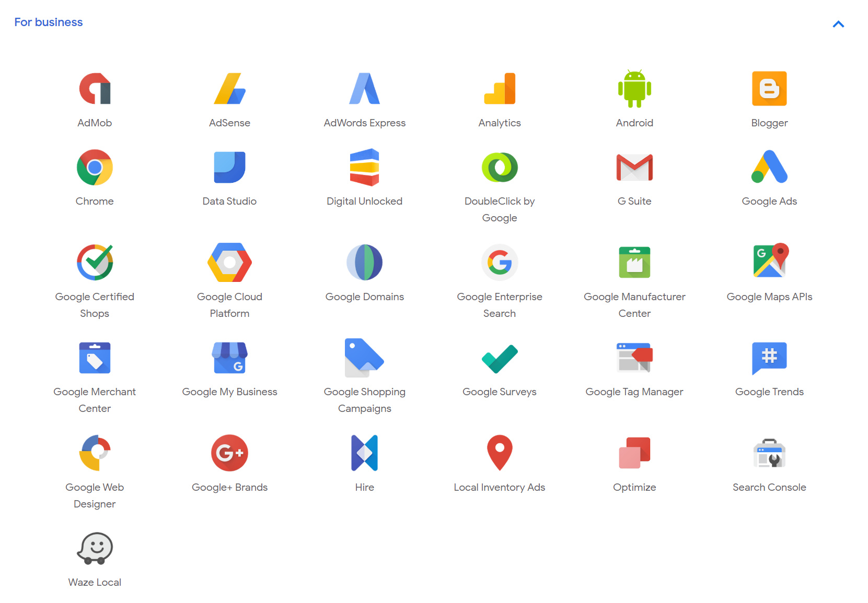

## Google Search

Google Search, also referred to as Google Web Search or simply Google is a web search engine developed by Google LLC. It is the most-used search engine on the World Wide Web, handling more than three billion searches each day. As of July 2018, it is the most used search engine worldwide across all platforms with 90.46% market share.

## Gmail

Gmail is a free, advertising-supported email service developed by Google. Users can access Gmail on the web and using third-party programs that synchronize email content through POP or IMAP protocols. Gmail started as a limited beta release on April 1, 2004, and ended its testing phase on July 7, 2009. At launch, Gmail had an initial storage capacity offer of one gigabyte per user, a significantly higher amount than competitors offered at the time. Today, the service comes with 15 gigabytes of storage. Users can receive emails up to 50 megabytes in size, including attachments, while they can send emails up to 25 megabytes.

## Google+

Google Plus (stylized as Google+) is an Internet-based social network that is owned and operated by Google. It was launched in June 2011. Features included the ability to post photos and status updates to the stream or interest-based communities, group different types of relationships (rather than simply "friends") into Circles, a multi-person instant messaging, text and video chat called Hangouts, events, location tagging, and the ability to edit and upload photos to private cloud-based albums.

## YouTube

YouTube allows users to upload, view, rate, share, add to favourites, report, comment on videos, and subscribe to other users. It offers a wide variety of user-generated and corporate media videos. Available content includes video clips, TV show clips, music videos, short and documentary films, audio recordings, movie trailers, live streams, and other content such as video blogging, short original videos, and educational videos. Most of the content on YouTube is uploaded by individuals, but media corporations including CBS, the BBC, Vevo, and Hulu offer some of their material via YouTube as part of the YouTube partnership program. Unregistered users can only watch videos on the site, while registered users are permitted to upload an unlimited number of videos and add comments to videos.

## Google Chrome

Google's Chrome for Android is an edition of Google Chrome released for the Android system. On February 7, 2012, Google launched Google Chrome Beta for Android 4 (Ice Cream Sandwich) devices, for selected countries. The first stable version of the browser was released on June 27, 2012. Chrome 18.0.1026.311, released on September 26, 2012, was the first version of Chrome for Android to support Intel x86 based mobile devices.

## Google Play Store

Google Play (previously Android Market) is a digital distribution service operated and developed by Google. It serves as the official app store for the Android operating system, allowing users to browse and download applications developed with the Android software development kit (SDK) and published through Google.

## Google Play Games

Google Play Games is an online gaming service and software development kit operated by Google for the Android operating system. It features gamer profiles, cloud saves, social and public leaderboards, achievements, and real-time multiplayer gaming capabilities. The Play Games service allows developers to incorporate the above features into their games without having to develop those features from scratch themselves. The Google Play Games service was introduced at the Google I/O 2013 Developer Conference, and the standalone Google Play Games mobile app was launched for Android on July 24, 2013.

## Google Play Music

Google Play Music is a music and podcast streaming service and online music locker operated by Google. The service was announced on May 10, 2011, and after a six-month, invitation-only beta period, it was publicly launched on November 16, 2011. Users with standard accounts can upload and listen to up to 50,000 songs from their personal libraries at no cost. A paid Google Play Music subscription entitles users to on-demand streaming of any song in the Google Play Music catalogue, as well as access to YouTube Music Premium.

## Google Play Books

Google Play Books (formerly Google eBooks) is an eBook digital distribution service operated by Google. Users can purchase and download eBooks and audiobooks from Google Play, which offers over five million titles, with Google claiming it to be the "largest eBooks collection in the world". Books can be read on a dedicated Books section on the Google Play website, through the use of a mobile app available for Android and iOS, through the use of select e-readers that offer support for Adobe Digital Editions and through a web browser. Users may also upload up to 1,000 eBooks in the PDF or EPUB file formats. Google Play Books is available in 75 countries.

## Google Drive

Google Drive is a file storage and synchronization service developed by Google. Launched on April 24, 2012, Google Drive allows users to store files on their servers, synchronize files across devices, and share files. Google Drive offers users 15 gigabytes of free storage, with 100 gigabytes, 1 terabyte and 2 terabytes, offered through optionally paid plans. Users can change privacy settings for individual files and folders, including enabling sharing with other users or making content public.

## Google Docs, Google Sheets, and Google Slides

They are a word processor, a spreadsheet and a presentation program respectively, all part of a free, based software office suite offered by Google within its Google Drive service. The suite allows users to create and edit files online while collaborating with other users in real-time. Edits are tracked by the user with a revision history presenting changes. An editor's position is highlighted with an editor-specific colour and cursor. A permissions system regulates what users can do. Updates have introduced features using machine learning, including "Explore", offering search results based on the contents of a document.

## Google Calendar

Google Calendar is a time-management and scheduling calendar service developed by Google. Google Calendar allows users to create and edit events. Reminders can be enabled for events, with options available for type and time. Event locations can also be added, and other users can be invited to events. Users can enable or disable the visibility of special calendars, including Birthdays, where the app retrieves dates of births from Google contacts.

## Google Keep

Google Keep is a note-taking service developed by Google. Launched on March 20, 2013, Google Keep is available on the web and has mobile apps for the Android and iOS mobile operating systems. Keep offers a variety of tools for taking notes, including text, lists, images, and audio. Users can set reminders, which are integrated with Google Now. Text from images can be extracted using optical character recognition, and voice recordings can be transcribed. The interface allows for a single-column view or a multi-column view. Notes can be colour-coded, and labels can be applied to the organization.

## Google Photos

It is a photo sharing and storage service developed by Google. It was announced in May 2015 and spun out from Google+, the company's social network. Google Photos gives users free, unlimited storage for photos up to 16 megapixels and videos up to 1080p resolution. The service automatically analyses photos, identifying various visual features and subjects. Users can search for anything in photos, with the service returning results from three major categories: People, Places, and Things.

## Google Pay

Google Pay (formerly Pay with Google and Android Pay) is a digital wallet platform and online payment system developed by Google to power in-app and tap-to-pay purchases on mobile devices, enabling users to make payments with Android phones, tablets or watches. As of January 8, 2018, the old Android Pay and Google Wallet have unified into a single pay system called Google Pay.

## Google Maps

It is a web mapping service developed by Google. It offers satellite imagery, street maps, 360° panoramic views of streets (Street View), real-time traffic conditions (Google Traffic), and route planning for travelling by foot, car, bicycle (in beta), or public transportation. Google Maps began as a C++ desktop program at Where 2 Technologies. In October 2004, the company was acquired by Google, which converted it into a web application. After additional acquisitions of a geospatial data visualization company and a real-time traffic analyser, Google Maps was launched in February 2005.

## Google Earth

It is a computer program that renders a 3D representation of Earth based on satellite imagery. The program maps the Earth by superimposing satellite images, aerial photography, and GIS data onto a 3D globe, allowing users to see cities and landscapes from various angles. Users can explore the globe by entering addresses and coordinates, or by using a keyboard or mouse. The program can also be downloaded on a smartphone or tablet, using a touchscreen or stylus to navigate. Google Earth is able to show various kinds of images overlaid on the surface of the earth and is also a Web Map Service client. In addition to Earth navigation, Google Earth provides a series of other tools through the desktop application. Additional globes for the Moon and Mars are available, as well as a tool for viewing the night sky.

## Google Expeditions

Google Expeditions is a virtual-reality teaching tool that allows you to lead or join immersive virtual trips all over the world – get up close to historical landmarks, dive underwater with sharks and even visit outer space! Built for the classroom and small group use, Google Expeditions allows a teacher acting as a “guide” to lead classroom-sized groups of “explorers” through collections of 360° and 3D images while pointing out interesting sights along the way.

## Google Waze

Waze is a GPS navigation software that works on smartphones and tablets with GPS support. It provides turn-by-turn navigation information and user-submitted travel times and route details while downloading location-dependent information over a mobile telephone network. Waze describes its app as a community-driven GPS navigation app, which is free to download and use. Waze won the Best Overall App award at the 2013 Mobile World Congress, beating Dropbox, Flipboard and others.

## Google Trips

Google Trips is a trip planner mobile app developed by Google for the Android and iOS operating systems. Google Trips allows users to plan for upcoming trips by summarizing info about the user's destination in several categories such as day plans, reservations, and things to do. The mobile app also facilitates locating flight, hotel, car, and restaurant reservations for the trip based on emails from the user's Gmail.

## Google Hangouts

Google Hangouts is a communication platform developed by Google which includes messaging, video chat, SMS and VOIP features. It replaces three messaging products that Google had implemented concurrently within its services, including Google Talk, Google+ Messenger (formerly: Huddle), and Hangouts, a video chat system present within Google+.

## Google Allo

It is an instant messaging mobile app by Google for the Android and iOS mobile operating systems, with a web client available on Google Chrome, Mozilla Firefox, and Opera. The app uses phone numbers as identifiers and allows users to exchange messages, files, voice notes and images. It includes a virtual assistant, a feature that generates automatic reply suggestions, and an optional encrypted mode. Users can resize messages and add doodles and stickers on the images before sending them.

## Google Translate

Google Translate is a free multilingual machine translation service developed by Google, to translate the text. It offers a website interface, mobile apps for Android and iOS, and an API that helps developers build browser extensions and software applications. Google Translate supports over 100 languages at various levels and as of May 2017, serves over 500 million people daily.

## Google Classroom

Google Classroom is a free web service developed by Google for schools that aim to simplify creating, distributing and grading assignments in a paperless way. The primary purpose of Google Classroom is to streamline the process of sharing files between teachers and students. Google Classroom combines Google Drive for assignment creation and distribution, Google Docs, Sheets and Slides for writing, Gmail for communication, and Google Calendar for scheduling. Students can be invited to join a class through a private code, or automatically imported from a school domain. Each class creates a separate folder in the respective user's Drive, where the student can submit work to be graded by a teacher.

## Google Scholar

Google Scholar is a freely accessible web search engine that indexes the full text or metadata of scholarly literature across an array of publishing formats and disciplines. Released in beta in November 2004, the Google Scholar index includes most peer-reviewed online academic journals and books, conference papers, theses and dissertations, preprints, abstracts, technical reports, and other scholarly literature, including court opinions and patents.

## Google Web Designer

Google Web Designer is a program for Windows, Mac and Linux from Google for creating interactive HTML5 ads and other HTML5 content. It offers a GUI with common design tools, such as a Text tool that integrates with Google Web Fonts, a Shapes tool, a Pen tool, and 3D tools. The advertising feature set includes components to add Google Maps, YouTube videos and more, as well as automatically including the tracking code events for DoubleClick and AdMob.

## Blogger

Blogger is a blog-publishing service that allows multi-user blogs with time-stamped entries. It was developed by Pyra Labs, which was bought by Google in 2003. The blogs are hosted by Google and generally accessed from a subdomain of blogspot.com. Blogs can also be served from a custom domain owned by the user (like www.example.com) by using DNS facilities to direct a domain to Google's servers. A user can have up to 100 blogs per account.

## Google Analytics

Google Analytics is a freemium web analytics service offered by Google that tracks and reports website traffic, currently as a platform inside the Google Marketing Platform brand. Google launched the service in November 2005 after acquiring Urchin. Google Analytics is now the most widely used web analytics service on the Internet. Google Analytics also provides an SDK that allows gathering usage data from iOS and Android Apps, known as Google Analytics for Mobile Apps.

## G-Suite

G Suite (formerly Google Apps for Work and Google Apps for Your Domain) is a brand of cloud computing, productivity and collaboration tools, software and products developed by Google, first launched on August 28, 2006, as "Google Apps for Your Domain". G Suite comprises Gmail, Hangouts, Calendar, and Google+ for communication; Drive for storage; Docs, Sheets, Slides, Forms, and Sites for collaboration; and, depending on the plan, an Admin panel and Vault for managing users and the services. While these services are free to use for consumers, G Suite adds enterprise features such as custom email addresses at a domain (@yourcompany.com), option for unlimited cloud storage (depending on plan and number of members), additional administrative tools and advanced settings, as well as 24/7 phone and email support. As of January 2017, G Suite has 3 million paying businesses and 70 million G Suite for Education users.

## Google AdSense

Google AdSense is a program run by Google that allows publishers in the Google Network of content sites to serve automatic text, image, video, or interactive media advertisements, that are targeted to site content and audience. These advertisements are administered, sorted, and maintained by Google. They can generate revenue on either a per-click or per-impression basis. Google beta-tested a cost-per-action service, but discontinued it in October 2008 in favour of a DoubleClick offering (also owned by Google). In Q1 2014, Google earned US$ 3.4 billion ($13.6 billion annualized), or 22% of total revenue, through Google AdSense. AdSense is a participant in the AdChoices program, so AdSense ads typically include the triangle-shaped AdChoices icon. This program also operates on HTTP cookies. Over 14.3 million websites use AdSense.